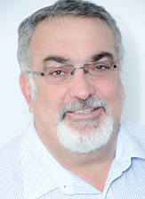Gary Feldman is representing the Financial Intermediary Association. He has been in the health care industry for 20 years. He is currently employed by NMG in the capacity of Regional Director and is accredited with the Council of Medical Schemes as a health care broker.